2.56: a) 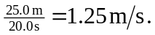
b)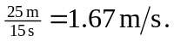

c) Her net displacement is zero, so the average velocity has zero magnitude.
d) 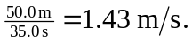 Note that the answer to part (d) is the harmonic mean, not the arithmetic mean, of the answers to parts (a) and (b). (See Exercise 2.5).

